**Agenda**

* Project update

Notes about repeatability:

* Figure out a pace that you can pump the head beforehand
  + Pneumatic for better controllability, but we don’t have an air pump so....
  + Dial indicator to find out displacement
    - Can hook up to arduino to get a read out
    - Get most popular, most likely have least problems
  + Try to go as slow as possible
* Suggestion:
  + Get a caliper and get a camera that records frames
    - load rate can be in terms of frames.
* Load Cell:
  + Max amount of load that the cell can take (50kg)
    - Might need more to break our thing
  + Load on bottom cons
    - Contact point changes
  + Load on top:
    - Sbeam load cell
    - 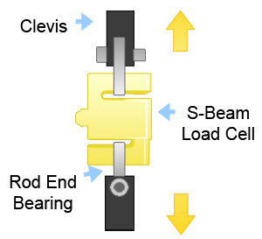
    - 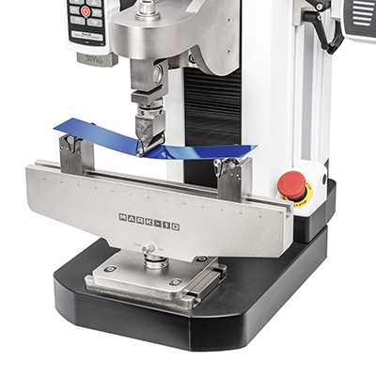
* Try clamps rather than using glue → something that really won’t budge (why not both?)
  + JB Weld <https://www.amazon.com/J-B-Weld-8265S-Cold-Weld-Reinforced/dp/B0006O1ICE#:~:text=J%2DB%20Weld%20is%20The%20Original,to%20a%20dark%20grey%20color>.

For next week:

* Prioritized list of experiments
  + Set up exactly what samples we want to test and how - data
  + Test plan!
  + Order shit let’s hop in a call for quick debrief?
* Keep in mind do good showcase (Nov. 1st!)

**Action Items:**

* Parts ordered
* First “cut” at prioritized test plan
* Do good video

Test rig:

* Controlling strain rate once we have press
* Do good work start next week